CSA 283: Exam One

Name: ______________________________________ Section: _____ _____

Please write legibly. Ask questions if something is unclear. Be concise in written answers.
Exam is printed on both sides!

You may use the Java 2 Platform Std. Ed. 6.0 documentation at

http://java.sun.com/javase/6/docs/api/.

You may not use any other documentation or notes unless you want to get a zero for the exam. You must take the exam in pencil.

Some useful formulas:
d_{trans} = L/R d_{prop} = d/s

Questions:

- List the five protocol layers of the Internet in order from lowest to highest. (5 points)

_______________________,

_______________________,

_______________________,

_______________________,

_______________________,

- Host A contacts host B. After a handshaking protocol is completed, host B sends data to host A. Host A processes the data and stores it for later retrieval. (6 points)

In the above scenario, which host is the client and which is the server?

Client: _______________

Server: _______________

Why?

- Give definitions for the following terms using one or two sentences. If the term is an acronym, also state what the letters in the acronym stand for and give a definition.
(15 points)

a. Cookie:

b. RFC:

c. Bit torrent chunk:

d. Traffic Intensity:

d. TDM:

- List three reasons DNS uses a distributed database instead a centralized database.
(6 points)

________________________________

________________________________

________________________________

- Below is an HTTP protocol message. Answer the questions about the message.

GET /fruit/kiwi.gif HTTP/1.1
Host: www.movesinstitute.org
Connection: close
User-agent: Mozilla/4.0
If-modified-since: Wed, 01 Oct 2003 09:23:34

- Was the message sent by a client or server? (2 points)

- What does the header line “If-modified-since:” mean? How will this affect the response to the message? (4 points)

- What does the header line “Connection: close” mean? Is this normal for HTTP 1.1? How could multiple objects be sent quicker? (4 points)
The header line “Connection: close” means that the client does not want to keep the connection open. The client does not want to reuse this connection. This is not normal for HTTP 1.1 because it uses persistence connection. When use “Connection: close”, the client is specifically want to use non-persistent connection.
Multiple objects could be send quicker by not using the “Connection: close” message. HTTP 1.1 uses persistent connection as a default.

- Consider the following scenario:

You are designing a networked application. It is a peer to peer application in which peers exchange sensor data. Each peer should receive a complete record of all of the sensor data from all other peers. Once the data is received, it is stored for retrieval at a later time. Which transport layer protocol would you use to support this application? Why? (5 points)

- Use the constants below to answer the following questions. Show work for partial credit. Indicate the units for each answer. Show times to four decimal places. Assuming processing and queuing delays are negligible.

File Size 30 Mb
Packet Size 0.5 Mb
Link Bandwidth 100 Mbs
Link Lengths 250 Kilometers
Propagation Speed 2.5 x 10⁸ Kms

- Calculate the propagation delay for a single link. (2 points)

- Calculate the transmission delay for a single packet and a single router.
(2 points)

- When the last bit of first packet leaves the transmitting host, where is the first bit of the packet? (3 points)

- Assuming there are five links connected by routers as depicted below. If processing and queuing delays are negligible, how much time will be required for a single packet to travel from A to B. (4 points)
A
B

- Again assume and queuing delays are negligible. For pipelined transmission with a transmission window of infinite size (A continuously transmits packets as fast as possible), calculate the time needed for the entire file to travel from A to B. (6 points)

- Consider the following scenario:

mailfwd.uc.edu is a mail server that wants to upload email for Oscar@npr.org to the npr.org mail server. In the following, assume that all nodes cache DNS records. All DNS caches initially empty. The first query sent by mailfwd.uc.edu is handled recursively. Assume all other queries are handled recursively as well. DNS server names are as follows:

Top level domain DNS server, edu: dns.tld.edu
Top level domain DNS server, org: dns.tld.org
Local Name server, uc: local.uc.edu
Local Name server, npr: local.npr.org
Authoritative DNS, npr: dns.npr.org
Authoritative DNS, uc: dns.uc.edu
Root DNS server: dns.root
Mail server, uc: mailfwd.uc.edu
Mail server, npr: mailfwd.npr.org

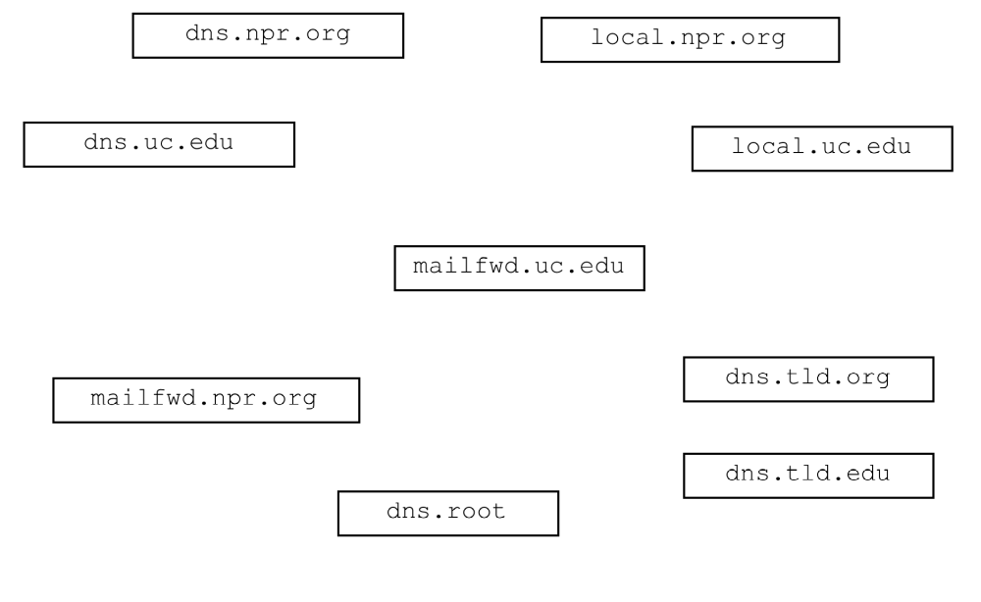Draw arrows labeled with numbers to indicate the order of queries and responses sent before mailfwd.uc.edu receives the IP address of mailfwd.npr.org.
(12 points)
What type of resource record would initially be sought by mailfwd.uc.edu? (circle one) (2 points)

Type A Type NS Type CNAME Type MX
- Assume the sequence in the previous question has just occurred and mailfwd.uc.edu has the IP address for mailfwd.npr.org. (10 points)

- What application layer protocol will mailfwd.uc.edu use to transfer the email message to mailfwd.npr.org?

___________________

- What transport layer protocol will mailfwd.uc.edu use while transferring the message?

___________________

- Which machine will be the client?

___________________

- Which machine will be the server?

___________________

- Once the email message is stored by mailfwd.npr.org, what public domain application protocol might be used to download the message?

___________________

- Networks can be circuit switched or packet switched. Consider the characteristics below and identify which type of network the characteristic is associated with by writing either packet or circuit next to it as appropriate. (8 points)

______________ Bandwidth is reserved for each connection.

______________ Network bandwidth is shared using statistical multiplexing.

______________ Guaranteed time delay.

______________ There is no sharing of resources between connections.

______________ Connection setup required.

______________ Stores and forwards discrete “chunks” of data.

______________ Network bandwidth divided into pieces using techniques such as TDM and FDM.
______________ Aggregate resource demand can exceed available system bandwidth.

- Complete the TCP Server class on the next page. Do not worry about handling exceptions. Allow the constructor to throw all exceptions to the main. (26 points)
- The server is single threaded. It handles client sequentially.
- Clients contact the Server using TCP and send one int followed by some number of floats or a single int equal to -1 followed by nothing.
- Assuming single -1 is not sent, the leading int indicates how many floats are being sent, the Server calculates the sum of the floats and sends the sum back to the client as a float. The client may repeat this process as many times as it desires.
- The connection between the client and server is kept open until the client wishes to close it.
- When a user of the client no longer wishes to send numbers, the client sends a -1 and both the client and the server close the connection. The server will continue to run and process numbers from other clients.
- The Server listens for clients on port number 31200.

- Implement a simple UDP client on page 9. Do not worry about handling exceptions. Allow the constructor method to throw them to the main. (30 points)

- The Client sends an int followed by some number of floats or a single int equal to -1in single datagram using UDP to a server.
- Assuming single -1 is not sent, the leading int indicates how many floats are being sent, the Server calculates the sum of the floats and sends the sum back to the client as a float in a single datagram. The client prints out the sum. The client may repeat this process as many times as it desires.
- The connection between the client and server is kept open until the client wishes to close it.
- When a user of the client no longer wishes to send numbers, the client sends a datagram containing -1 and both the client and the server close the connection. The server will continue to run and process numbers from other clients. The client will close.
- The Server listens for clients at 10.32.255.0 on port number 31200.
- Close all open sockets before the program exits.

Call the readNumbers method to read in all the floats that the user wants to send. It returns the numbers in an ArrayList of Float objects. If the size of the ArrayList is equal to 0, the users wishes to stop.

ArrayList<Float> x = readNumbers();

  - Getting the first float in the list:

x.get(0).floatValue();

  - Determining the size of the list:

int sizeOfList = x.size();

import java.io.*;
import java.net.*;

public class TCPSummSever{

public static void main(String[] args) throws Exception
{
new TCPSummSever();
}

public TCPSummSever() throws Exception
{
import java.io.*;
import java.net.*;
import java.util.Scanner;

public class UdpProductClient {

protected ArrayList<Float> readNumbers() { ... }

public static void main(String[] args) throws Exception
{
new UdpProductClient();
}

public UdpProductClient() throws Exception
{

